Rick and Morty

Rick Raids

With Ember entertainment

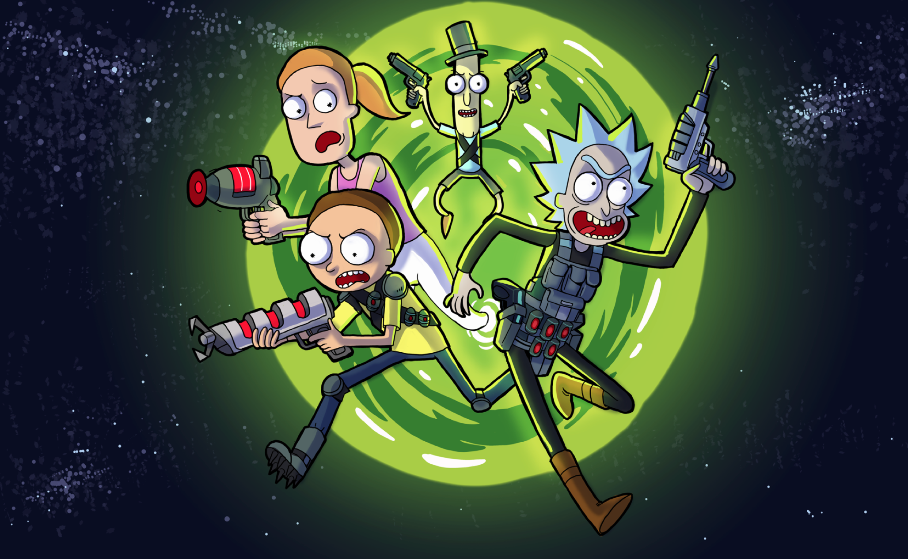

The Game Loop

1: Basic Combat - Battle with your Rick

2: Rewards - Get That Loot Crate!

3: Crafting – Do I Hear Sci-Fi Noises?

4: Smith Residence - Take the Family!

5: Customize – Show Me What You Got!

6: PVP – Fighting Other Ricks!

7: PVP Ladder - The Rickiest Rick!

8: Guild System - Council of Ricks!

9: Monetization – Get Those Schmekles!

10: Dev requirements and risks

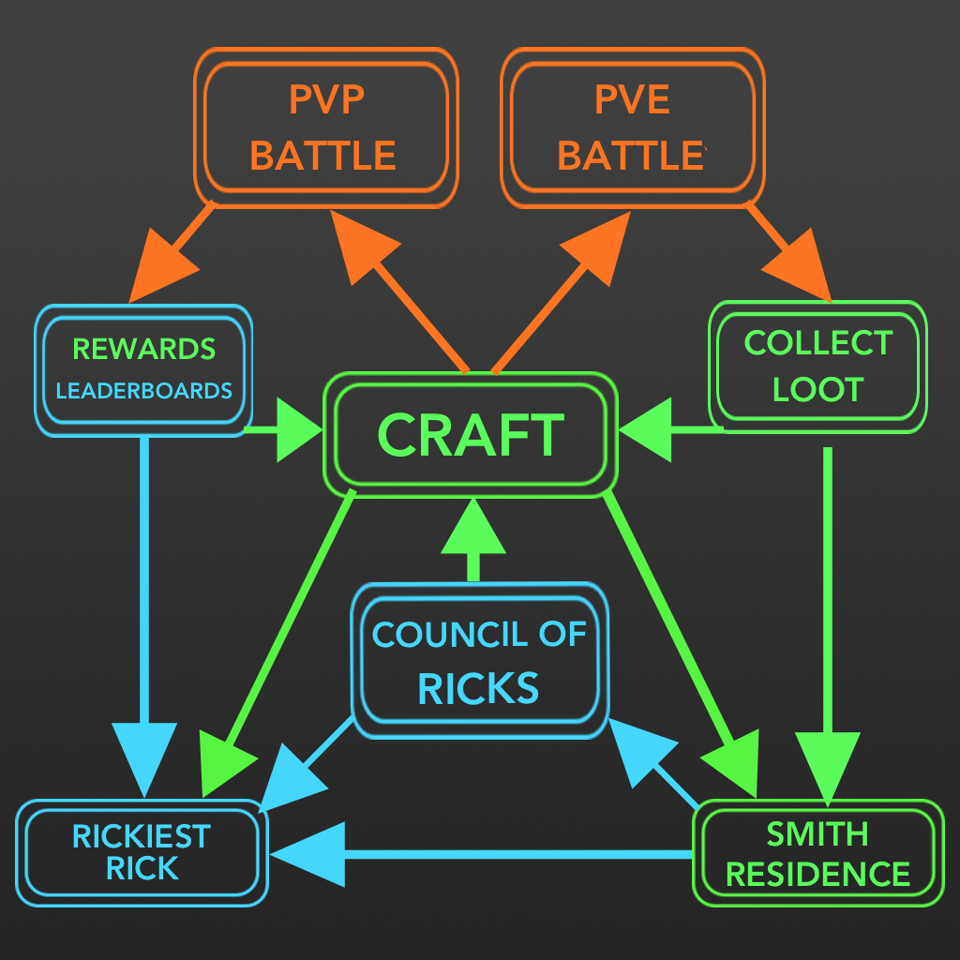

#### **1: BASIC COMBAT - BATTLE WITH YOUR RICK**

Take your Rick and Morty to fight off hordes of enemies in an arcade style shooter. The gameplay will move fast and be exciting with a lot of visual explosions, deaths and power ups to create an exciting experience.

**Gameplay Screen**

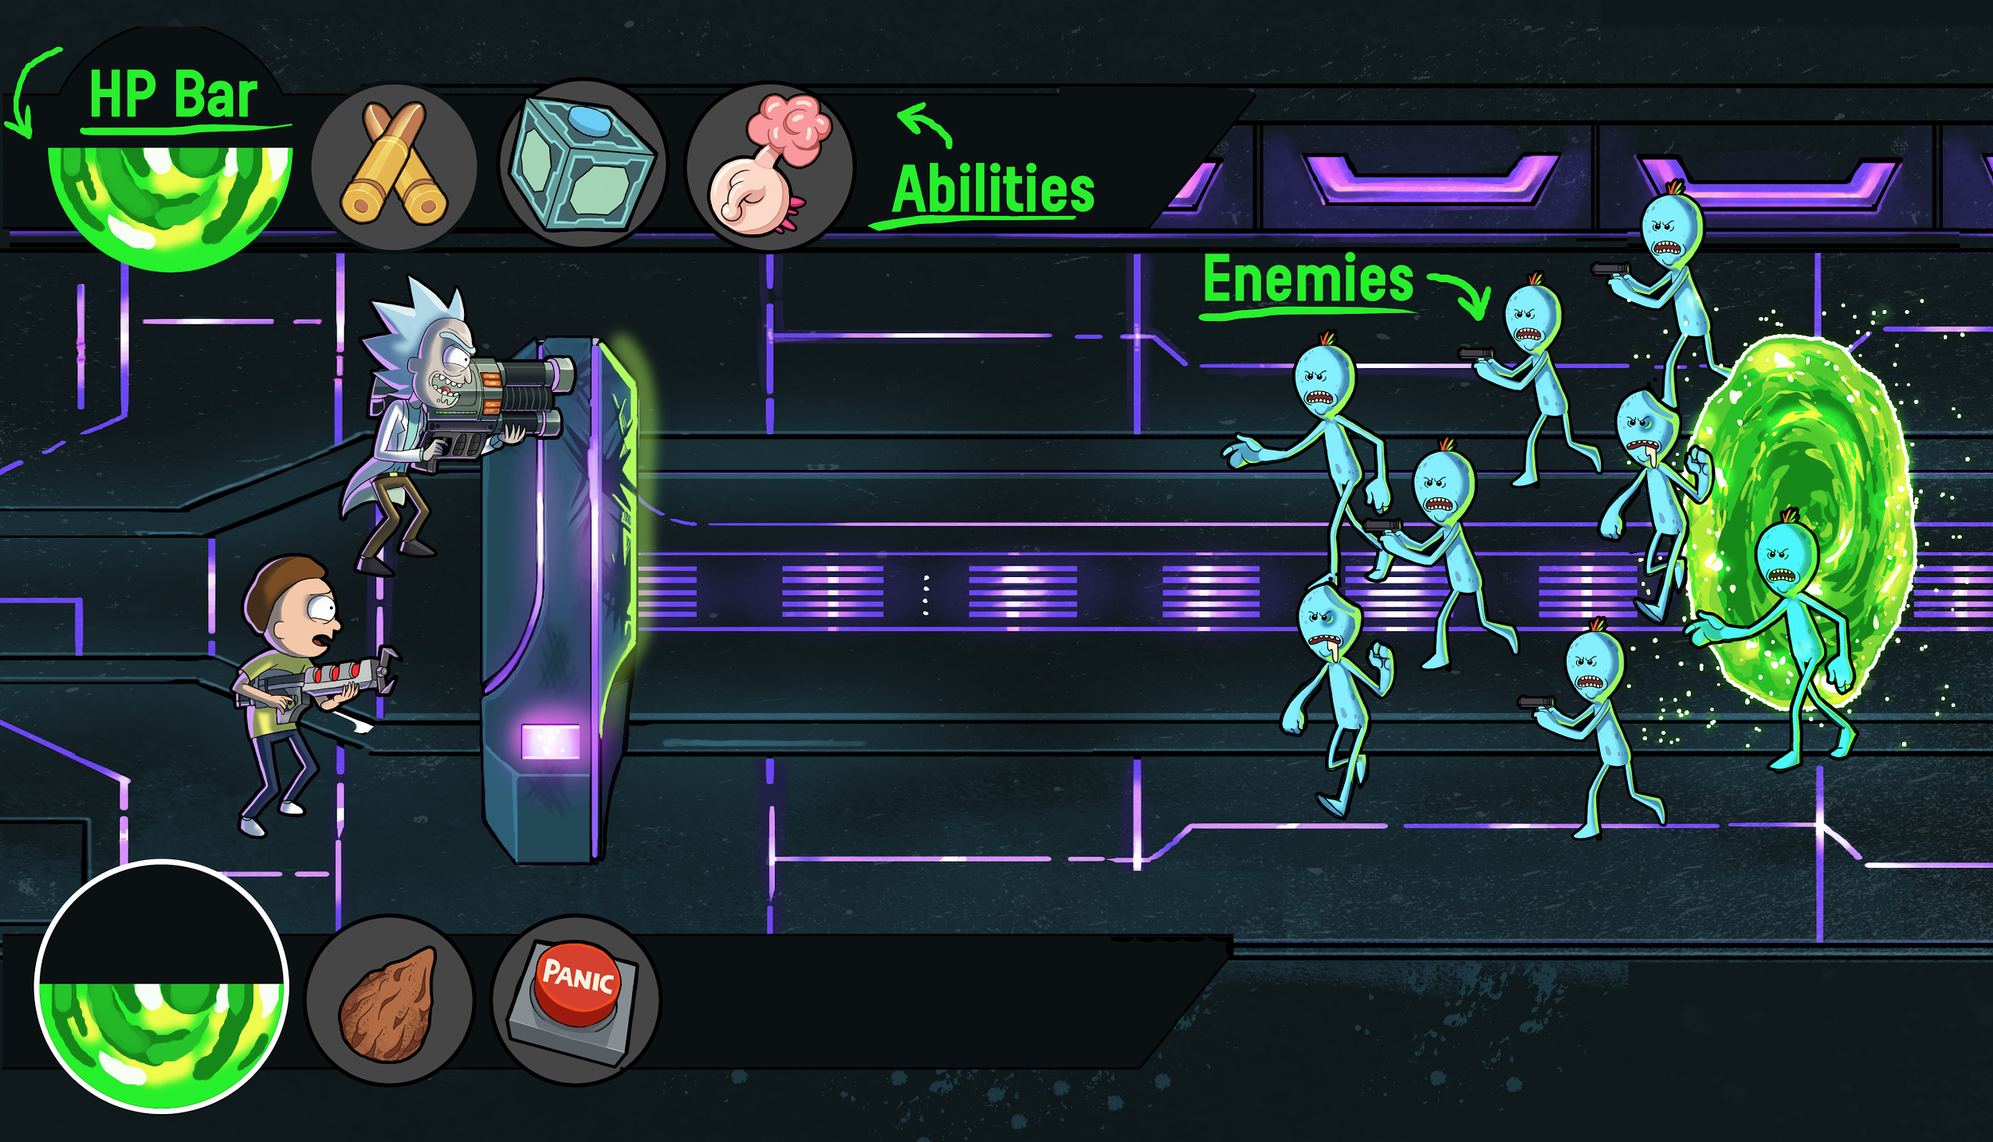

**Rick and Morty will continuously fire at wherever you are aiming.**

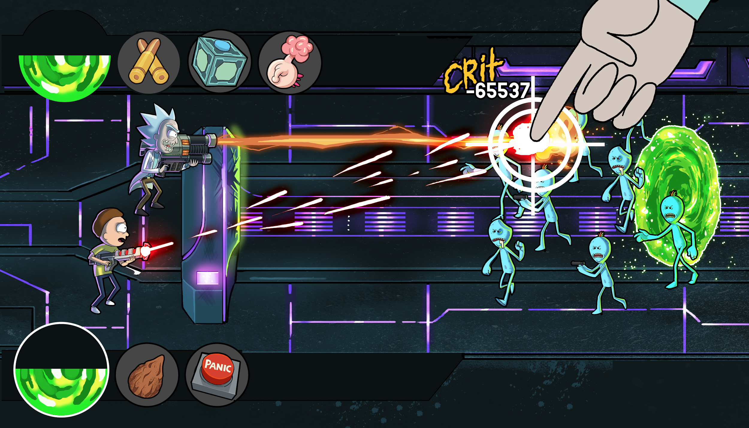

**Let Autoplay Fight For You!** Rick and Morty will attack targets on their own.

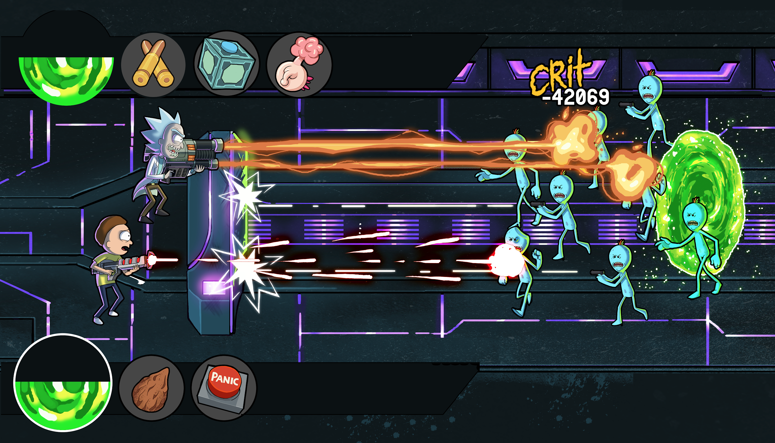

**Play through hundreds of levels and collect sweet loot!**

Play through hundreds of levels and find the most exciting power ups, craftable items, armor for your Rick and Morty.

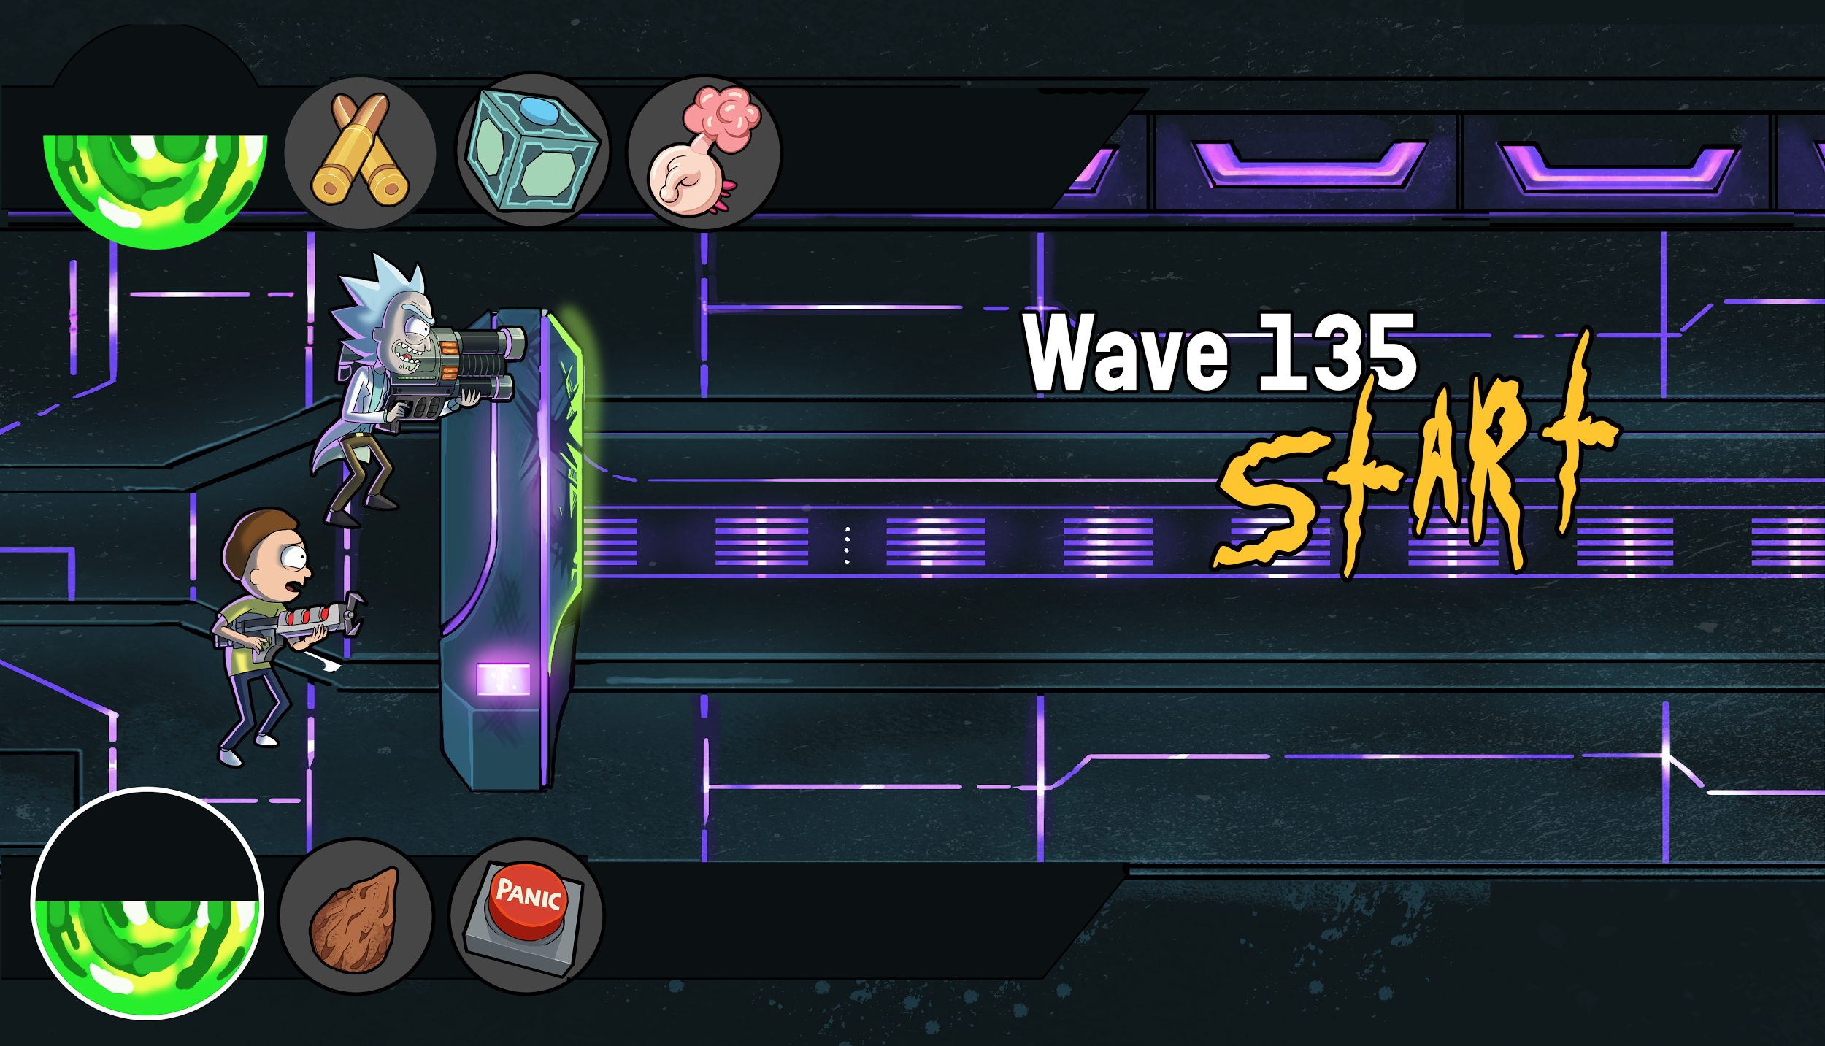

Battles cost energy, players can purchase more energy or wait for it to recharge. Players can also participate in an unlimited number of PVP battles with no energy cost.

#### **2: REWARDS - GET THAT LOOT CRATE!**

Collecting loot will help you make more powerful armor, better weapons and stronger units. Everything you do in the game will take collectible loot to make better.

Fighting against waves of enemies gives the player instant rewards! The further you get in the campaign of the game the better rewards you get.

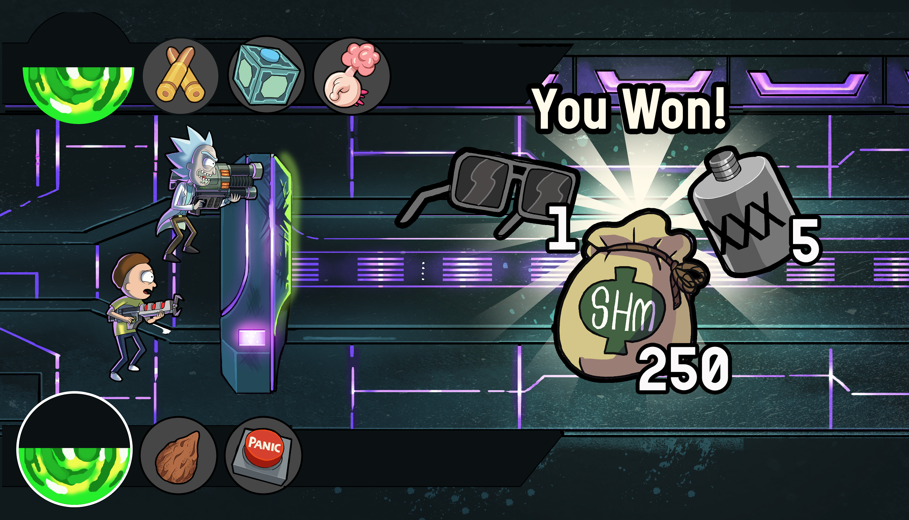

PVP victories earns the player chests! Chests can be opened immediately for a price, or the player can wait for the chests timer to reach zero to collect their rewards. The rarer the chest, the greater the loot.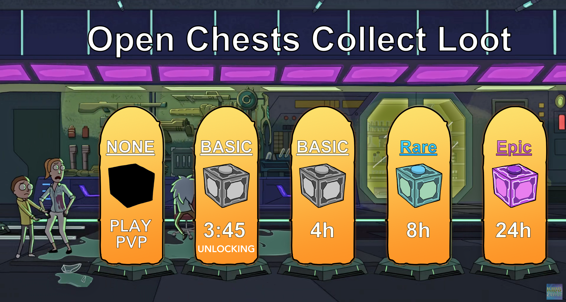

**3: Crafting - With Neural Networks  
“*Sometimes science is more art than science” - Rick Sanchez***

Rick’s amazing ability to think outside the box and create some of the most feared gadgets and weapons in the galaxy demands a crafting system that matches his reputation. At Ember we would be one of the first companies ever to use convoluted neural networks to create one of the deepest crafting systems ever put together. Players would be able to customize the position of each component of their weapon to produce a truly unique weapon. We would then take metadata from each of the crafting components to produce stats that are also unique to the weapon the player just made. This would give each and every player in the game the potential to have a weapon that is unique to their Rick and not found anywhere else in the game. We are excited for the chance to create this crafting system and know that the Rick and Morty multiverse is the perfect place for this new and exciting kind of crafting system.

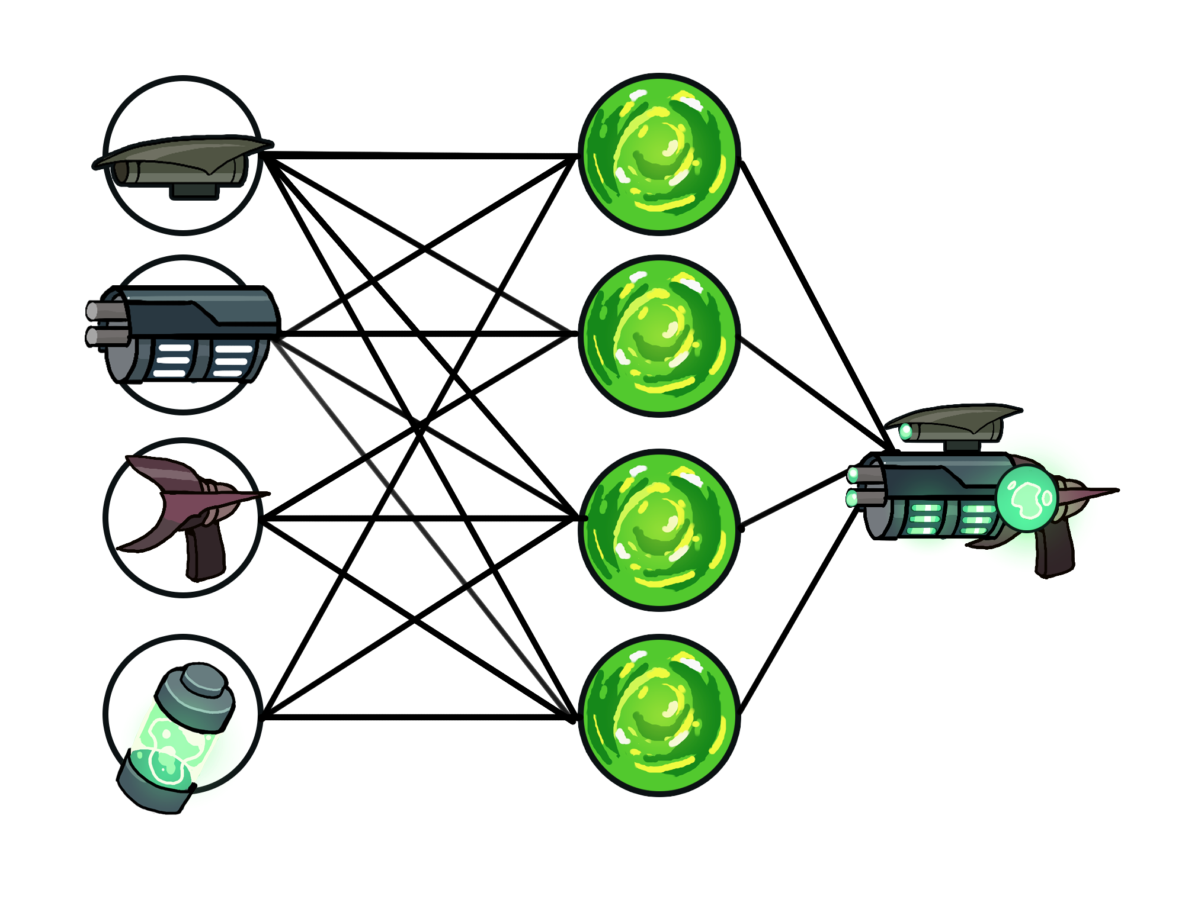

### **4: SMITH RESIDENCE - TAKE THE FAMILY!**

The smith residence is like your home screen and you will see the house in profile much like Tiny Tower, Fallout Shelter or Mega Mall. You will be able to add new rooms that provide unique buffs to your Smith Residence and customize the outside appearance of it. Every player should have the opportunity to make their Smith residence unique. The gameplay aspects of the Smith Residence are largely located underground and can be expanded by continuing to build downwards under the house.

In addition to housing many rooms and buffs you’ll be able to store and upgrade aliens, interdimensional species and bureaucrats to send in waves during PVP battles. Your waves of captured creates can be upgraded to help you advance towards becoming the Rickiest Rick.

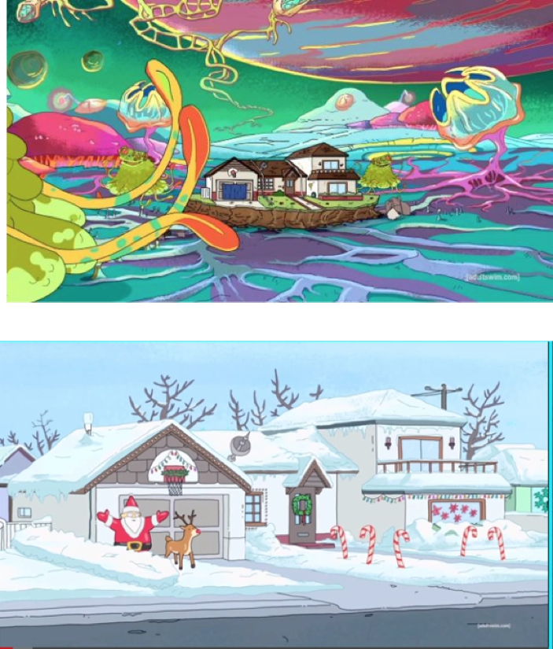

#### 

#### **5: CUSTOMIZE – SHOW ME WHAT YOU GOT!**

Part of the exciting thing about crafting and getting near gear is showing off what you have made and what your Rick and Morty look like. Collect new armor, gear, weapons and unique ways to customize your Smith residence. Every player’s Rick and Morty will get to be unique in some way and there will always be new content for you to share with your friends.

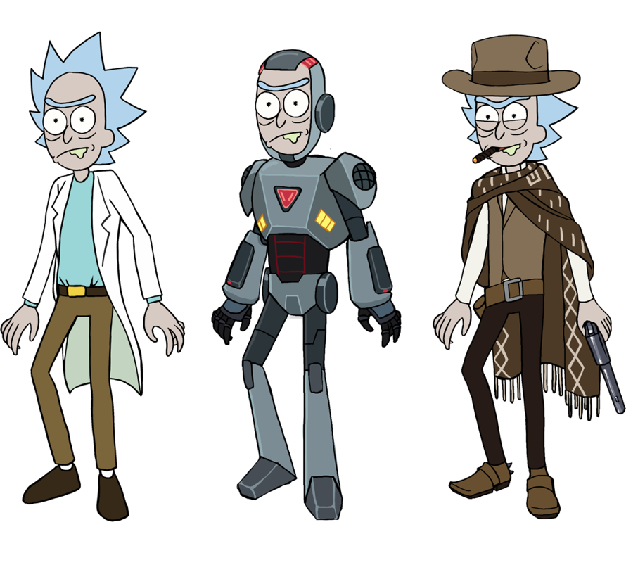

**The main ways to show off your Rick are:**

1. Play PVP Battles

2. Visit your Friend’s Smith Residence

3. Share your gear with your council.

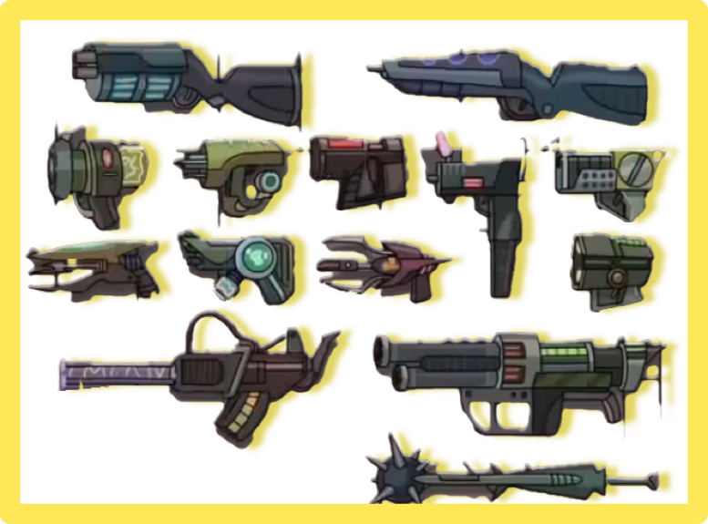

### **6: PVP – FIGHTING OTHER RICKS**

Fighting against other Ricks will be a part of a trophy based ladder ranking system (commonly found in top grossing mobile games). By fighting other Rick’s and climbing through the ladder, you will have the opportunity to be the Rickiest Rick.

The PVP gameplay involves your Rick and Morty squaring off against another Rick and Morty and sending waves of enemies at each other. The last Rick standing wins trophies and a timed chest if you have available space to store it.

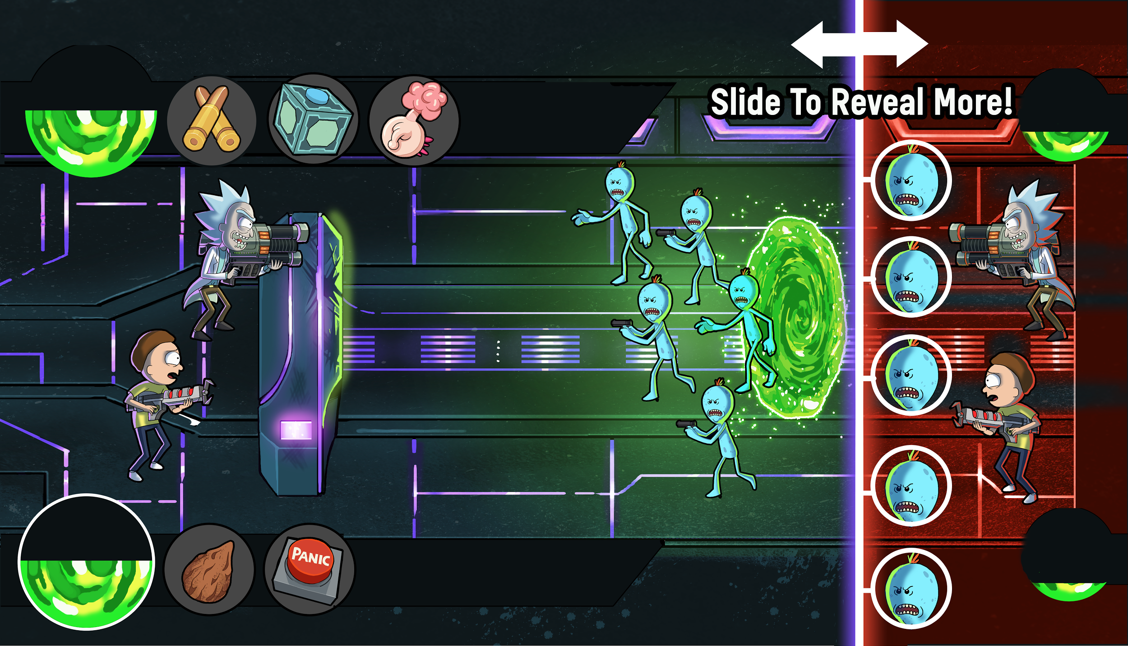



**Chest Screen**

7: PVP LADDER - THE RICKIEST RICK

Defeating other Ricks in the PVP system will earn you trophies needed to climb up the leaderboards! Winning battles earns you trophies and losing battles causes you to lose trophies. As you progress further up the leaderboards you’ll have access to some interesting perks and better loot from your chests. The PVP system will have seasons and player’s trophy counts will be reset after each season. When a player wins a season they will forever have a chat badge, unique piece of gear or customizable item that shows off that for a season they were the Rickiest Rick.

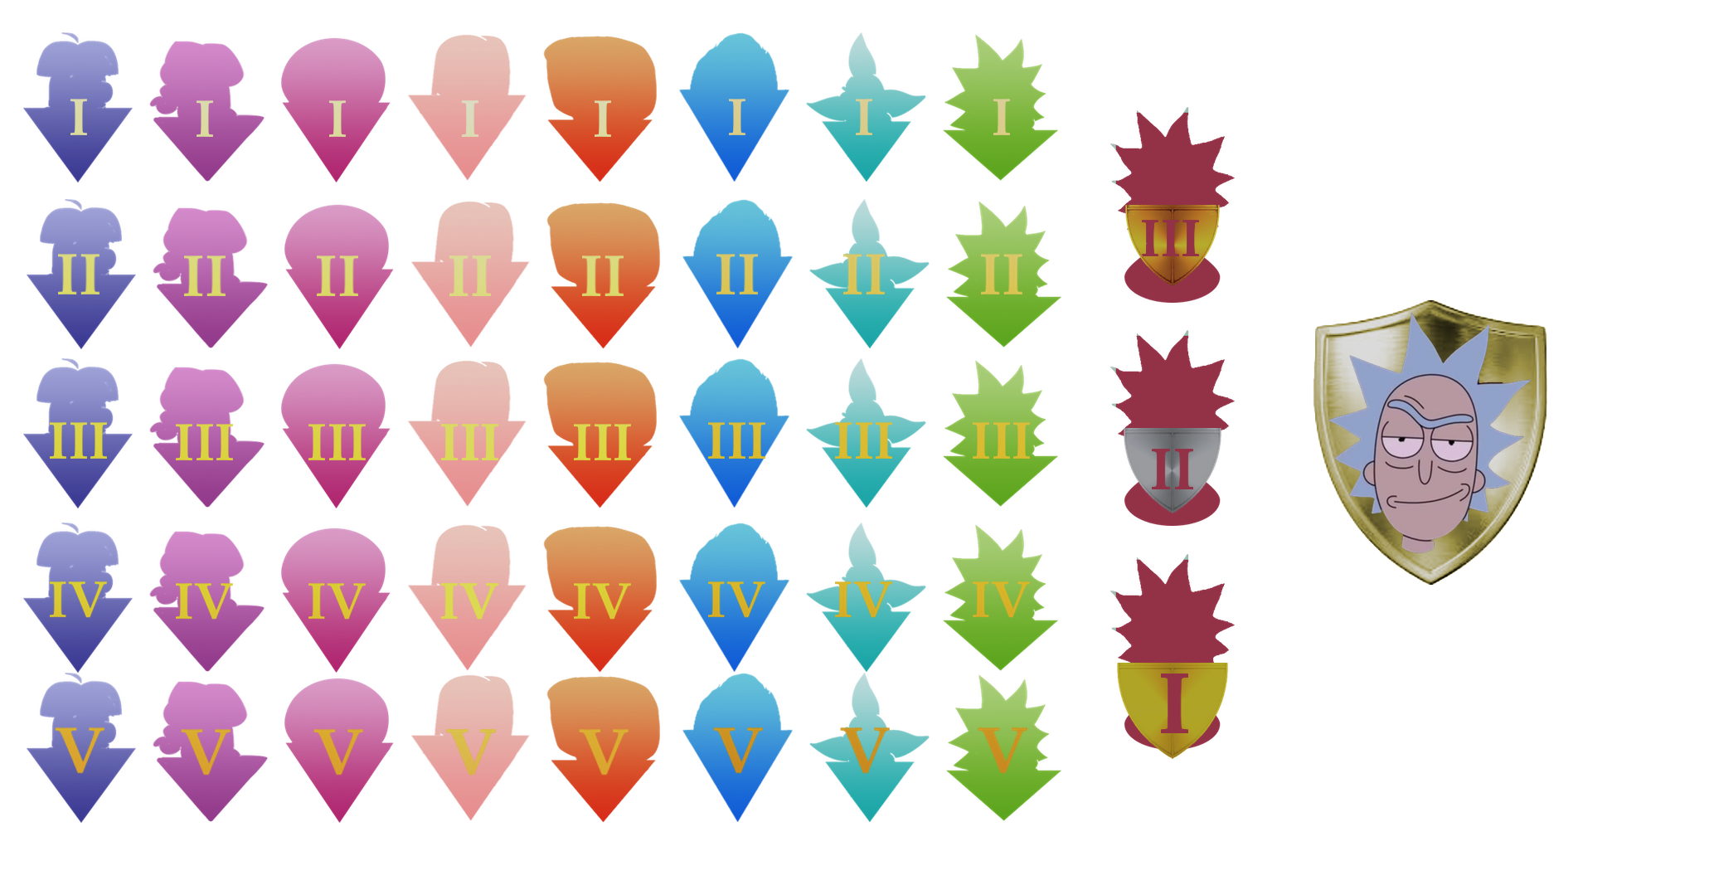

Leaderboards and PVP ladders are a great way to keep players engaged over a long period of time and continue to force players to explore new content and become more powerful.

### **8: GUILD SYSTEM - COUNCIL OF RICKS**

Social interactions are an important part of any mobile game, bringing people together encourages long term player retention and makes interactions more exciting. By teaming up with other Rick’s you’ll be able to share resources, share technology, discuss strategies, show off your customized equipment and play with your friends. The additional sharing available in your Council of Ricks will make your Rick get more powerful faster.

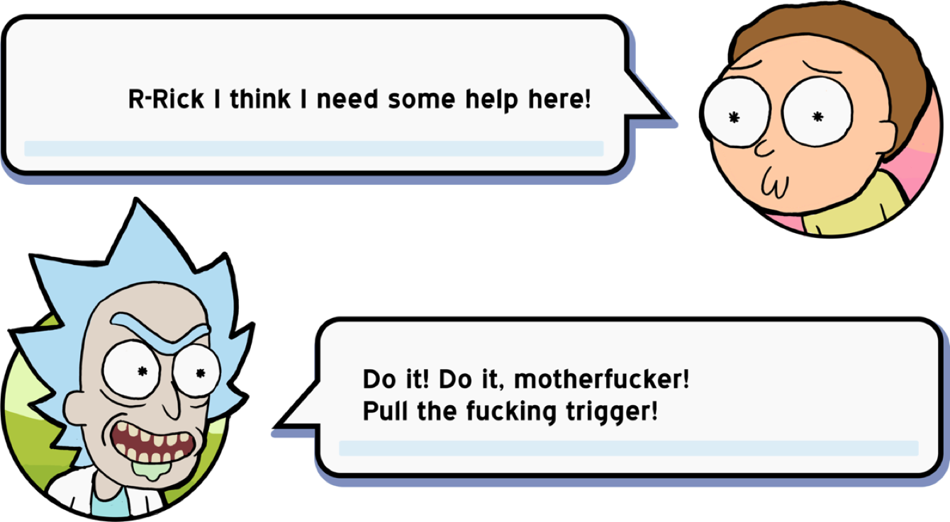

It sometimes helps add a little peer pressure as well.

**9: Monetization – EARNING SCHMEKLES**

* 1. Crafting Sinks
  + Instant complete crafting
  + Selling the player unique crafting items
  + Selling the player Power ups for crafted items
  + Easy content expansion post release
* 2. Gameplay Sinks
  + Purchasing more energy
  + Instant revives
  + Restocking gear
  + Temporary battle power ups
* 3. PVP Sinks
  + Improved gear and leveling up becomes more important
  + Speed up the opening of special PVP chests
  + Showing off your unique build makes customizing more exciting.
* 4. Customization Sinks
  + Creates long term retention by making the player feel like there is always more to discover.
  + Look awesome and share it on facebook
* 5. Subscriptions
  + This style of game is excellent for a subscription model.
  + It would be easy to provide a multitude of benefits that are subscription only and can hook a lot of players into providing steady revenue.

# 

# 

### 

### 

### 

### **10: Dev requirements and risks**

**Team Size**: 1 Product Manager, 1 Producer/Project Manager, 1 Art outsourcing specialist, 6 Programmers, 2 designers (UI/UX and Game Balancing Experience), 2 internal artists.

**Soft Launch**: 8 Months after having a full team

* Gameplay (combat) – Low Risk but will take a lot of development and polish time.
* Game Servers - Authoritative game server to stop cheating.
* Crafting – Technically Higher Risk, large development time and balance tuning, polish can be done after the game is shipped.
* 200+ Levels of enemies – Low risk, lots of design time.
* Basic global chat system – Low Risk, implemented in proprietary tech already.
* Basic sales system, verify that people are interesting in purchasing crafting and buffs. – Low risk, implemented in proprietary tech already.
* Analytics - Data necessary for balance tuning and evaluating KPI’s around retention and monetization.

**World Wide Launch**: 4 Months after soft launch

* Council of Rick System – Low Risk, guild systems are a known quantity.
* PVP Battles and Ladder System – High risk technically and from a design perspective. Accounting for more units on screen is a performance risk. Real time combat is a server risk, however we have implemented similar systems in previous games.
* Basic Friends List – Low risk yet essential any game with social features.
* 200+ additional levels – Same as above
* Improved sales and monetization loops – Increase monetization based on data taken from soft launch.

**Major Update 1**: 2 Months after world wide launch

* Smith Residence Feature
* Improvements to trophy system – Tuning based on data from World Wide Launch
* Increase crafting supplies, enemies you can make for PVP and additional levels – Low risk but content heavy.

**Biggest Risk**: Mobile development advertising has become increasingly complicated and expensive.